Northwind Traders — Power BI
Business Insight Report
Name: Mahendran K
Roll Number: 5272510209
Course: B.Com Fintech with AI — 2nd Year
Dataset: Northwind Traders

2. Introduction
Provide a brief overview of:
- Northwind Traders dataset
- Purpose of the dashboard
- Purpose of the Business Insight Report

3. Dashboard Overview
Dashboard Screenshot
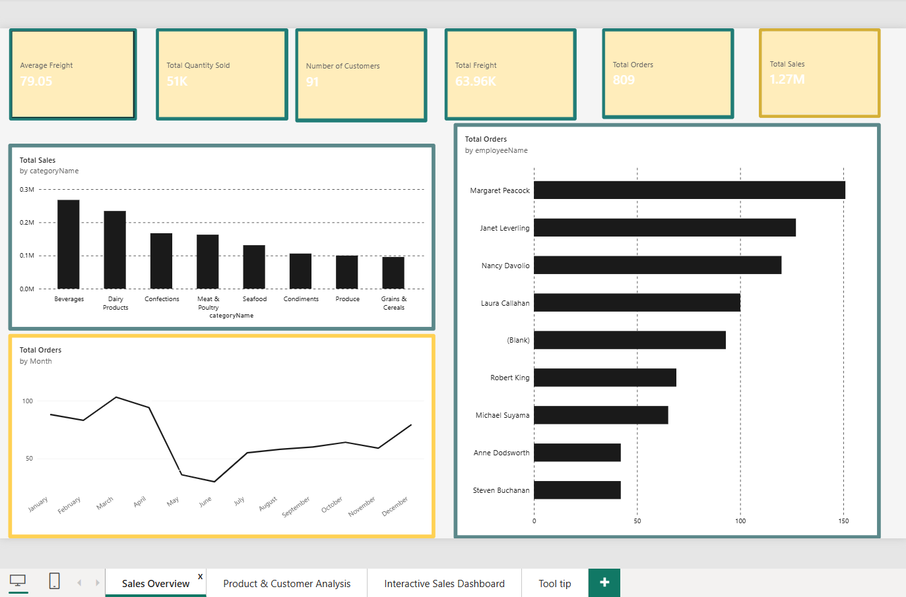
Fig 3.1 — Sales Overview page of the Northwind Interactive Sales Dashboard

Below the screenshot, include:
- Purpose of the dashboard
- Key components
- Interactive filters available
Students should mention:
- Year
- Region
- Category
Key components observed in this report:
- KPI cards
- Orders by Month
- Sales by Product Category
- Orders by Employee
- Category Tooltip

4. KPI Analysis
Discuss the following:

Total Orders
Explain what the value indicates about overall order activity.

Total Quantity Sold
Discuss the overall volume of products sold.

Total Freight
Interpret the freight value in relation to order activity.

Average Freight
Explain what the average freight value indicates.

No. of Customers
Discuss the customer coverage represented in the dataset.
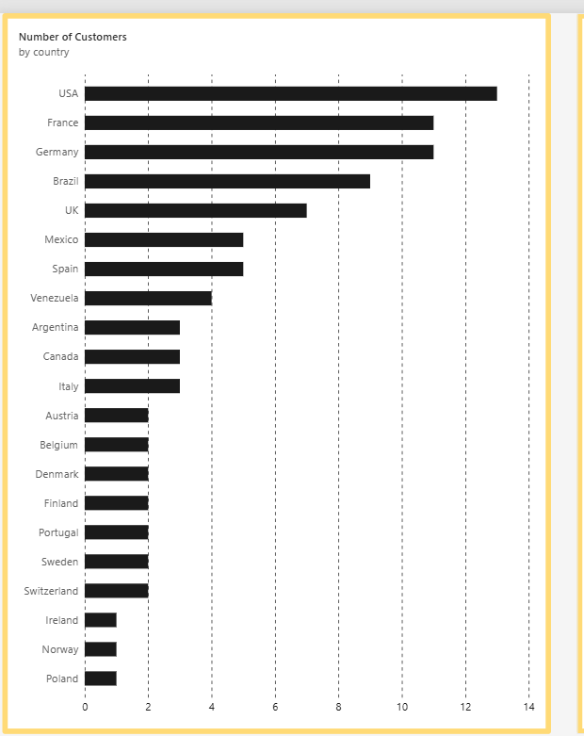
Fig 4.1 — Number of Customers by Country
Suggested Format
KPI | Value | Interpretation
Total Orders
Total Quantity Sold
Total Freight
Average Freight
No. of Customers

5. Product Category Performance Analysis
Students should analyse Sales by Product Category.
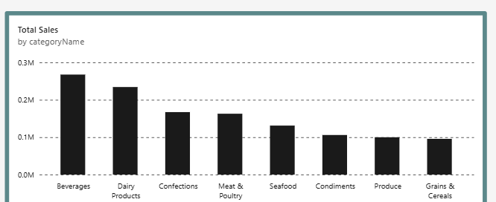
Fig 5.1 — Total Sales by Product Category
Discuss:
- Highest-selling category
- Lowest-selling category
- Relative differences
- Important observations
Key Insight

6. Monthly Order Trend Analysis
Students should analyse the Orders by Month chart.
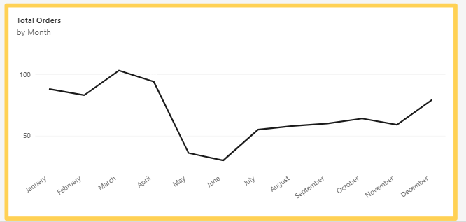
Fig 6.1 — Total Orders by Month
Discuss:
- Highest-order month
- Lowest-order month
- Overall pattern
- Major fluctuations
Key Insight

7. Regional / Filter-Based Analysis
Since the dashboard uses a Region slicer rather than a separate regional chart, students should demonstrate how the dashboard changes when different regions are selected.
Discuss:
- KPI changes
- Category changes
- Monthly order changes
- Employee performance changes
Suggested Format
Region | Major Observation | Business Insight
Region 1
Region 2
Region 3

8. Employee Performance Analysis
Students should analyse the Orders by Employee chart.
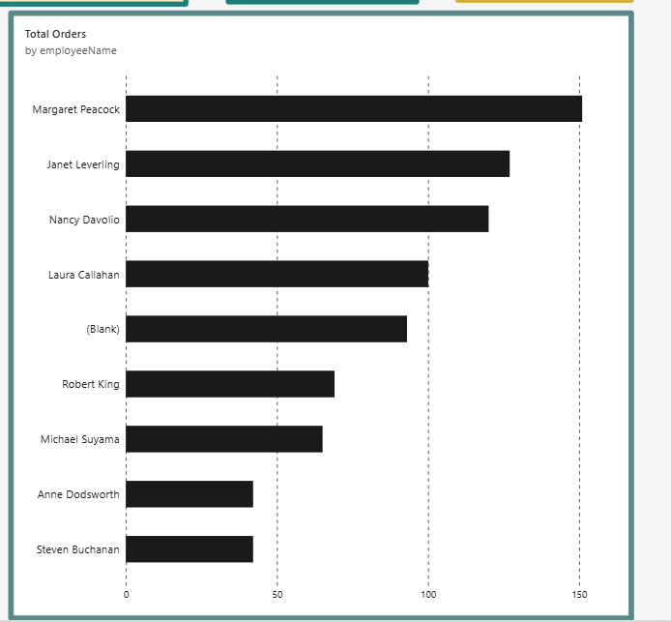
Fig 8.1 — Total Orders by Employee
Discuss:
- Highest-performing employee
- Lowest-performing employee
- Difference between employees
- Changes after applying filters
Key Insight

9. Business Insights
Students should identify at least three important business insights.
Insight 1

Insight 2

Insight 3

Students should remember:
Observation = What the data shows
Insight = What the observation means for the business

10. Business Recommendations
Students should provide at least five recommendations.
Recommendations may relate to:
- Product category planning
- Inventory planning
- Regional strategy
- Employee performance
- Monthly order planning
- Freight management
- Customer targeting
1.
2.
3.
4.
5.

11. Conclusion
Provide a brief summary of:
- Overall dashboard findings
- Most important business insight
- Key recommendation
- How Power BI helped in the analysis

